How to Fork a repository
https://docs.github.com/en/get-started/quickstart/fork-a-repo
Key term

fork
A fork is a personal copy of another user's repository that lives on your account. Forks allow you to freely make changes to a project without affecting the original upstream repository. You can also open a pull request in the upstream repository and keep your fork synced with the latest changes since both repositories are still connected.
https://docs.github.com/en/get-started/quickstart/github-glossary#commit
Login to GitHub
Click on the repository you want others to fork
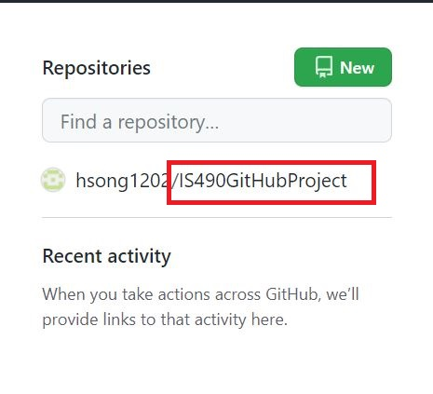
In the repository, click Code
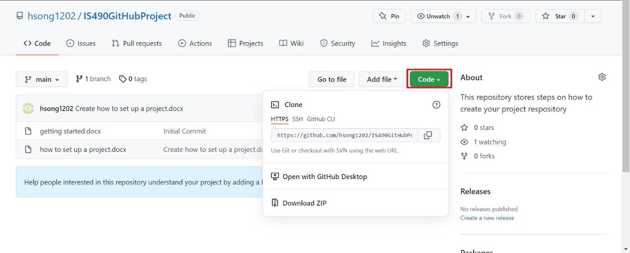
Copy the web address to the repository
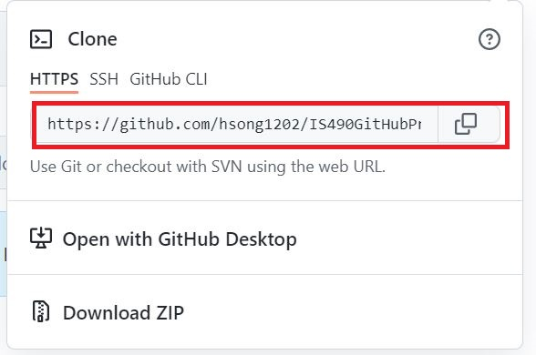
Share the address with students
Once the student fork the repository, you can see who forked the repository by viewing About section of the repository
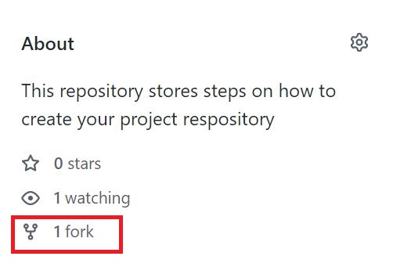
Click fork
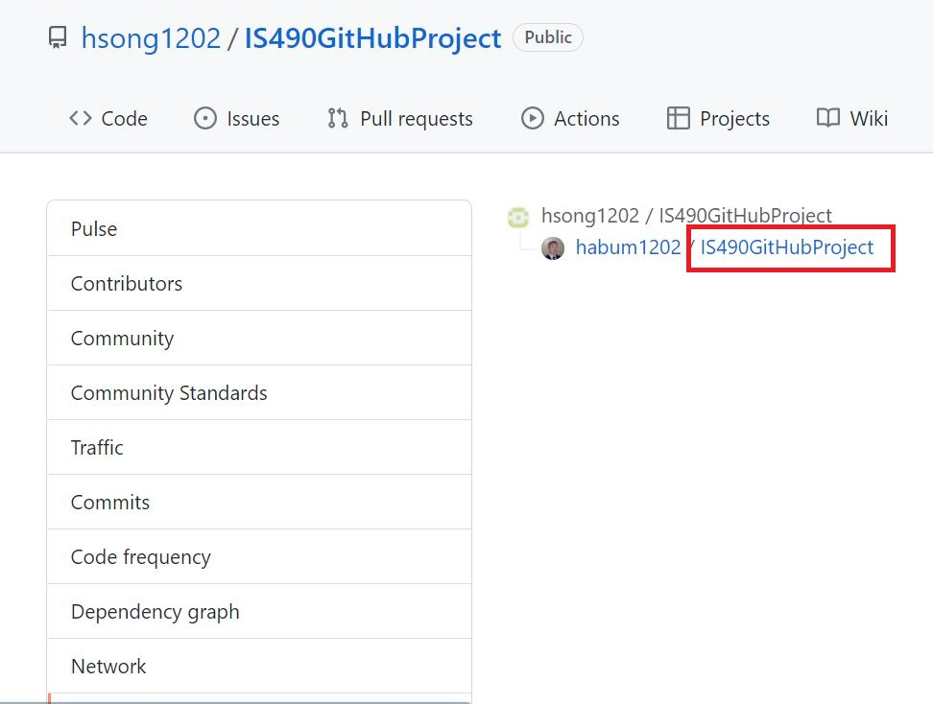
Click repository under forked individual
Click commits
